IAM- IDENTITY AND ACCESS MANAGEMENT

USERS AND USER GROUPS-

Objectives-

- – Access the IAM Dashboard
- – View the empty Users list
- – Create IAM user: pras-72
- – Attach AmazonS3FullAccess policy to pras-72
- – Retrieve and save credentials for pras-72
- – Create IAM user: pras-59
7 – Attach AmazonS3FullAccess policy to pras-59
8 – Review and confirm pras-59 creation
- – View the empty User Groups list
10 – Create group "Prastuti" and add both users
- – Attach AmazonS3FullAccess policy to the group
12 – Confirm group created successfully

Step 1: Access the IAM Dashboard-

Log in to the AWS Management Console. In the top search bar, type IAM and click on the IAM service result. This opens the Identity and Access Management dashboard.
The dashboard shows a full summary of IAM resources in your account. At this point the account has user groups, 0 users, 3 default roles, 0 policies, and 0 identity providers.
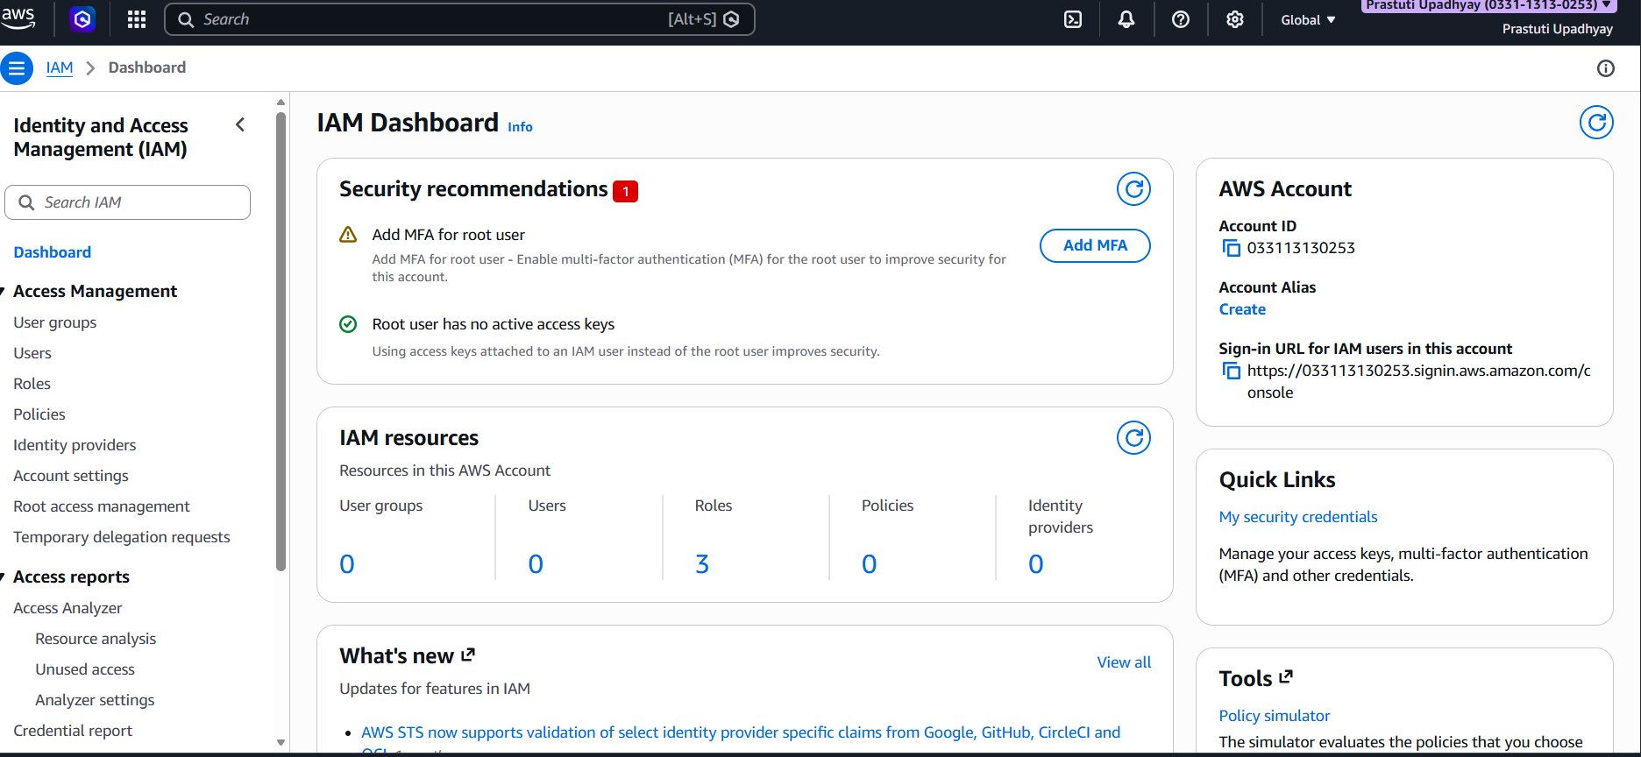

Step 2: Navigate to the Users List-

In the left sidebar under Access Management, click Users. The list is empty — "No resources to display" — since no IAM users have been created yet.
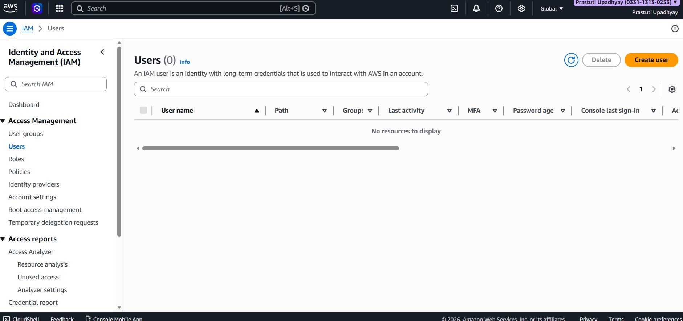
Step 3: Create IAM User: pras-72-

Click the orange Create user button (top right). On the User details page, fill in the following:
User name: pras-72.
Check "Provide user access to the AWS Management Console".
Console password: select Custom password and enter a secure password.
Leave "Users must create a new password at next sign-in" unchecked.
Click Next to proceed to the Set permissions step:

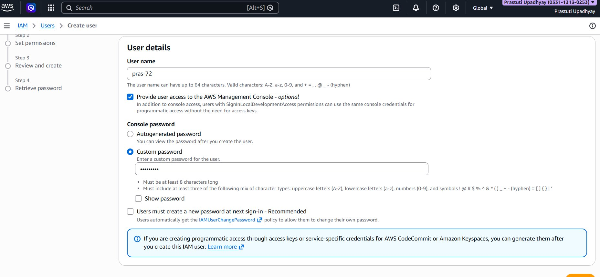
Step 4: Attach AmazonS3FullAccess Policy to pras-72-

On the Set permissions page, choose "Attach policies directly". In the search box, type s3. From the 17 matching results, check the box next to AmazonS3FullAccess (AWS managed). Click Next.
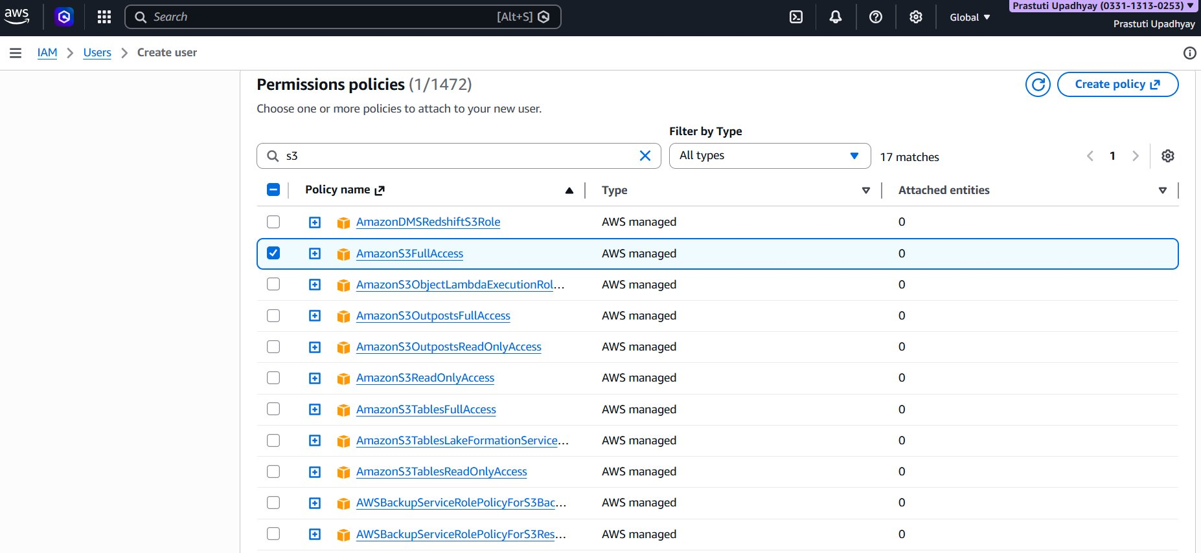

Step 5:Retrieve Credentials for pras-72-

After clicking Create user, you reach the Retrieve password page. This is the only time the password is visible. Save the credentials immediately using one of these options:
Click Show to view the password on screen.
Click Download.csv file to save credentials locally.
Click Email sign-in instructions to send via email.
The console sign-in URL for this account is: https://093456774536.signin.aws.amazon.com/console.

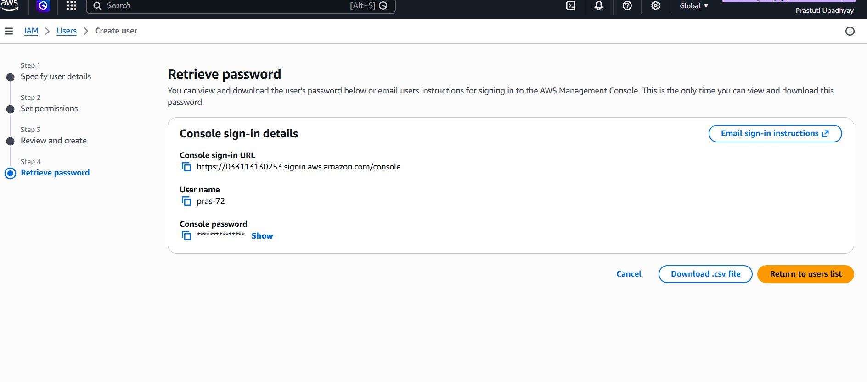
Step 6: Create IAM User: pras-59-

Go back to Users → Create user to create the second user. Fill in the details:
User name: pras-59.
Provide user access to the AWS Management Console: checked.
Console password: Custom password (enter a secure password).
Users must create a new password at next sign-in: unchecked.
Click Next to proceed.

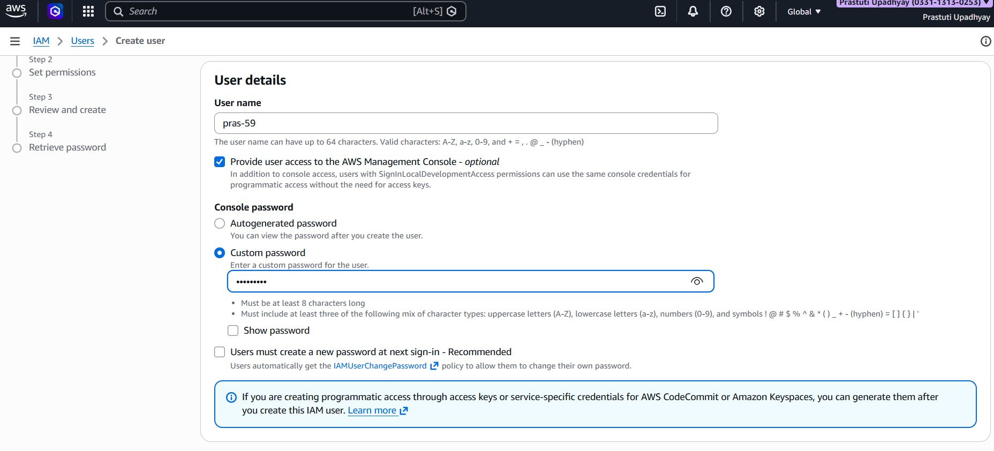

Step 7: Attach AmazonS3FullAccess Policy to pras-59-

On the Set permissions page, again choose "Attach policies directly". Search for s3 and select AmazonS3FullAccess. This grants pras-59 full access to all S3 buckets.

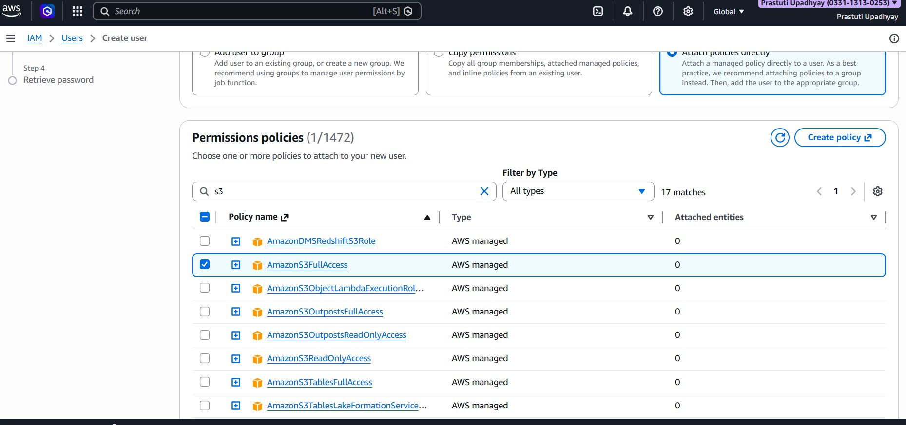
Step 8: Review and create pras-59-

The Review and create page shows a full summary before confirming. Verify the following details are correct.
User name: pras-59.
Console password type: Custom password.
Required password reset: No.
Permissions summary: AmazonS3FullAccess - AWS Managed – Permissions policy.
Click Create user to finish.

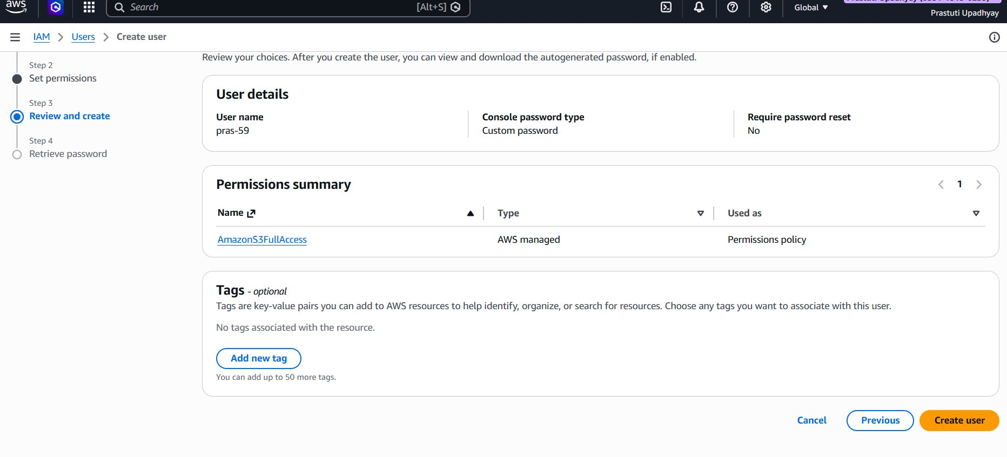

Step 9: Navigate to User Groups-

In the left sidebar under Access Management, click User groups. The list shows "No resources to display" — no groups exist yet. Click Create group to begin.

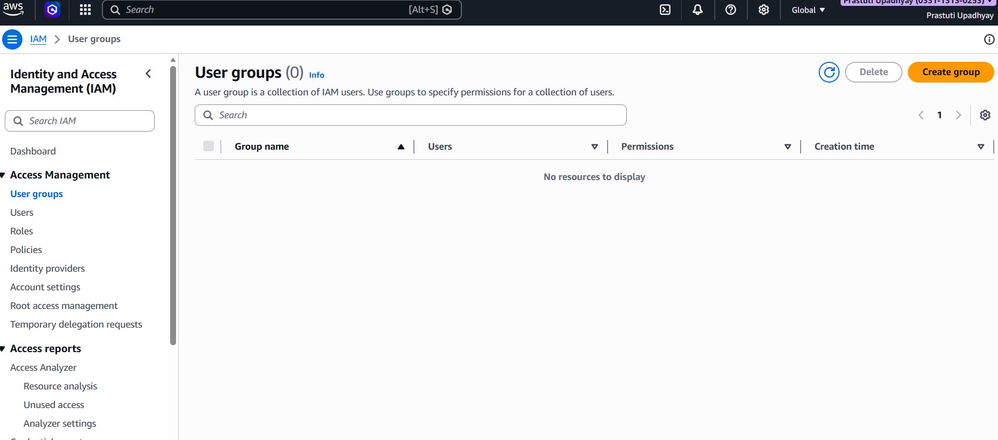

Step 10: Create Group “Prastuti” and Add Both Users-

On the Create user group page, enter the group name:
User group name: Prastuti.
Scroll down to "Add users to the group". Both existing users appear in the list. Check both boxes to add them:
pras-59.
pras-72.

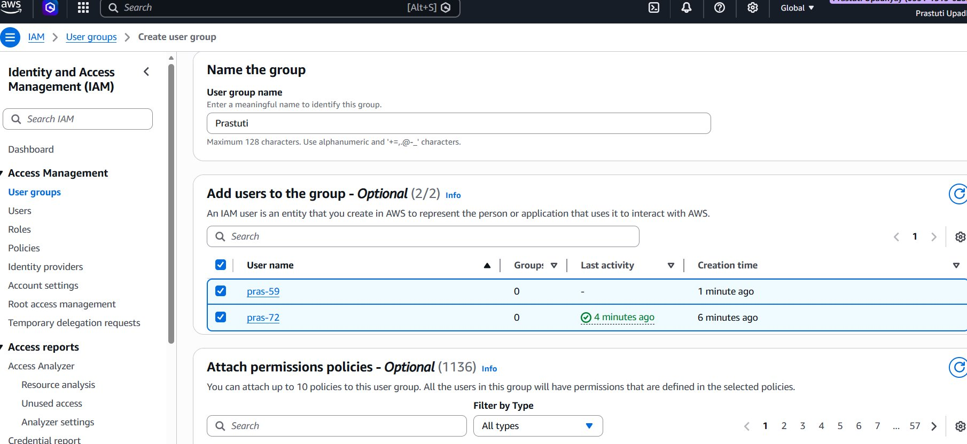
Step 11: Attach AmazonS3FullAccess Policy to the Group-

Still on the Create user group page, scroll down to "Attach permissions policies". Search for s3 in the filter box. Check AmazonS3FullAccess (AWS managed). This policy will apply to all users in the group.
Click Create user group to finalize.

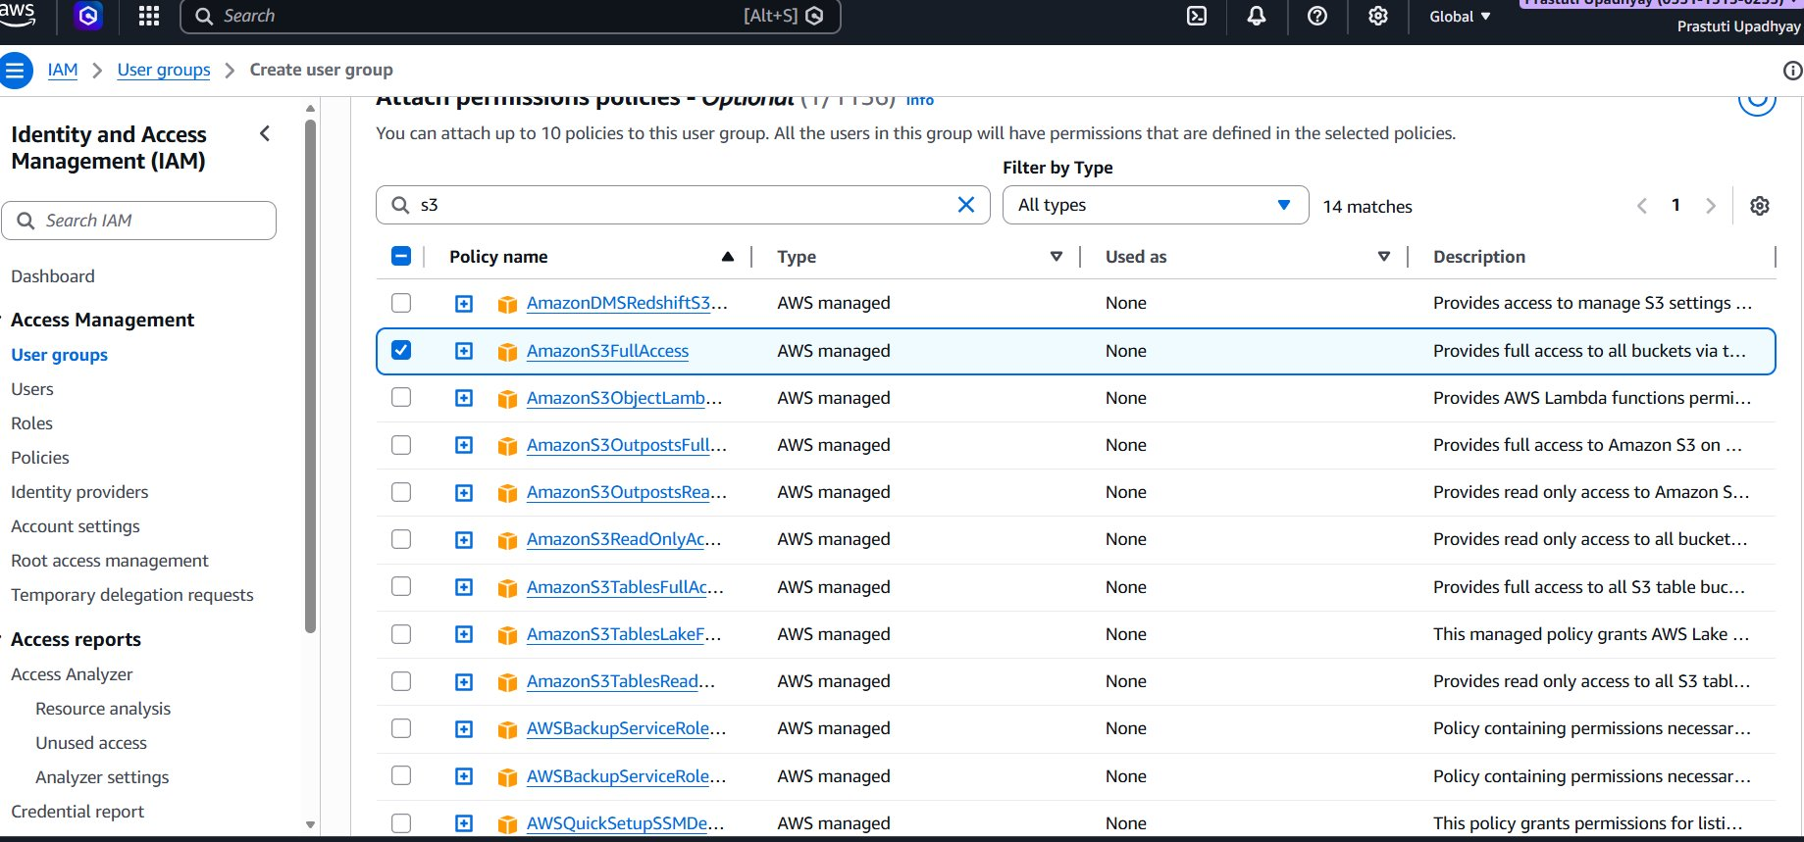

Step 12: User Group Created Successfully-

The User Groups list now shows the newly created group:
Group name: Prastuti.
Users: 2 (pras-59 and pras-72).
Permissions: Defined (green checkmark).
Creation time: Now.

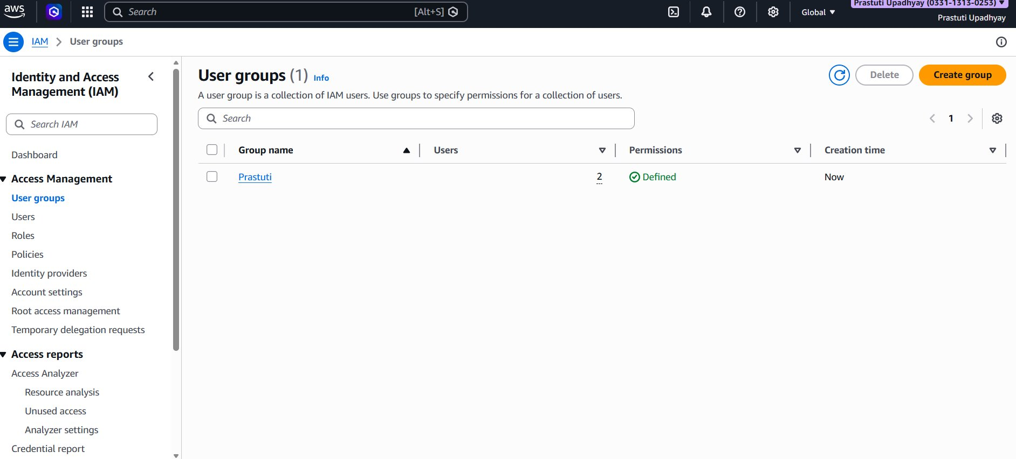

Step 12: User Group Created Successfully
The User Groups list now shows the newly created group:
- Group name: Prastuti
- Users: 2 (pras-59 and pras-72)
- Permissions: Defined (green checkmark)
- Creation time: Now


